Case-2

In this case if a patient object is having 1lakhs record to update this it will take a lot of time for this we have some tools which are not created by salesforce

Data loader

Import wizard

Work bench

Inspector

Per object we can create only 2 master relationships and 40 lookup relationships

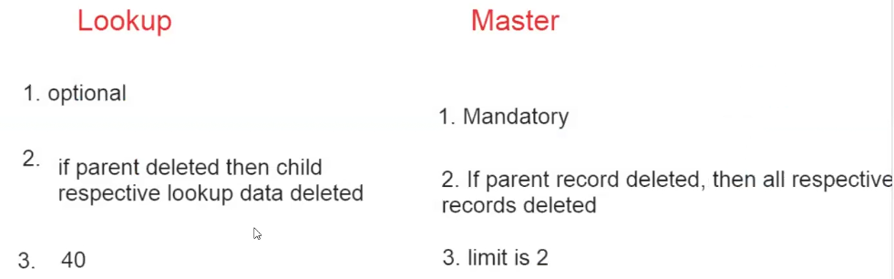

Sales force is going to provide editor to return some logic

After writing the logic in the editor when we submit it will go to complier to going validate our logic and then it moves to runtime engine giving the out put

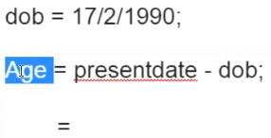

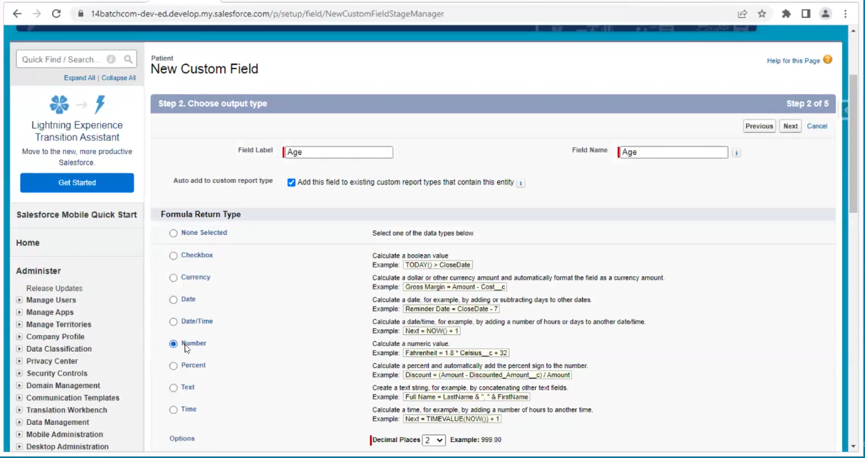

Display purpose labels

Logic purpose API names

